4ITRC2 Operating System Lab

Lab Assignment 2

**Outputs of the following commands**

1. **Pwd**(Prints the current working directory.)

/home/kanishk

1. **cd** - Changes the current directory.

cd Desktop

cd OS

pwd

output­🡪cd - Changes the current directory.

1. **ls** - Lists files and directories in the current directory.

abc.text defg.text first.sh hijk.text second.sh xyz.text

1. **mkdir -** Creates a new directory.

mkdir KANISHKBAGZA

5.**rm** - Removes files or directories. OUPUT🡪

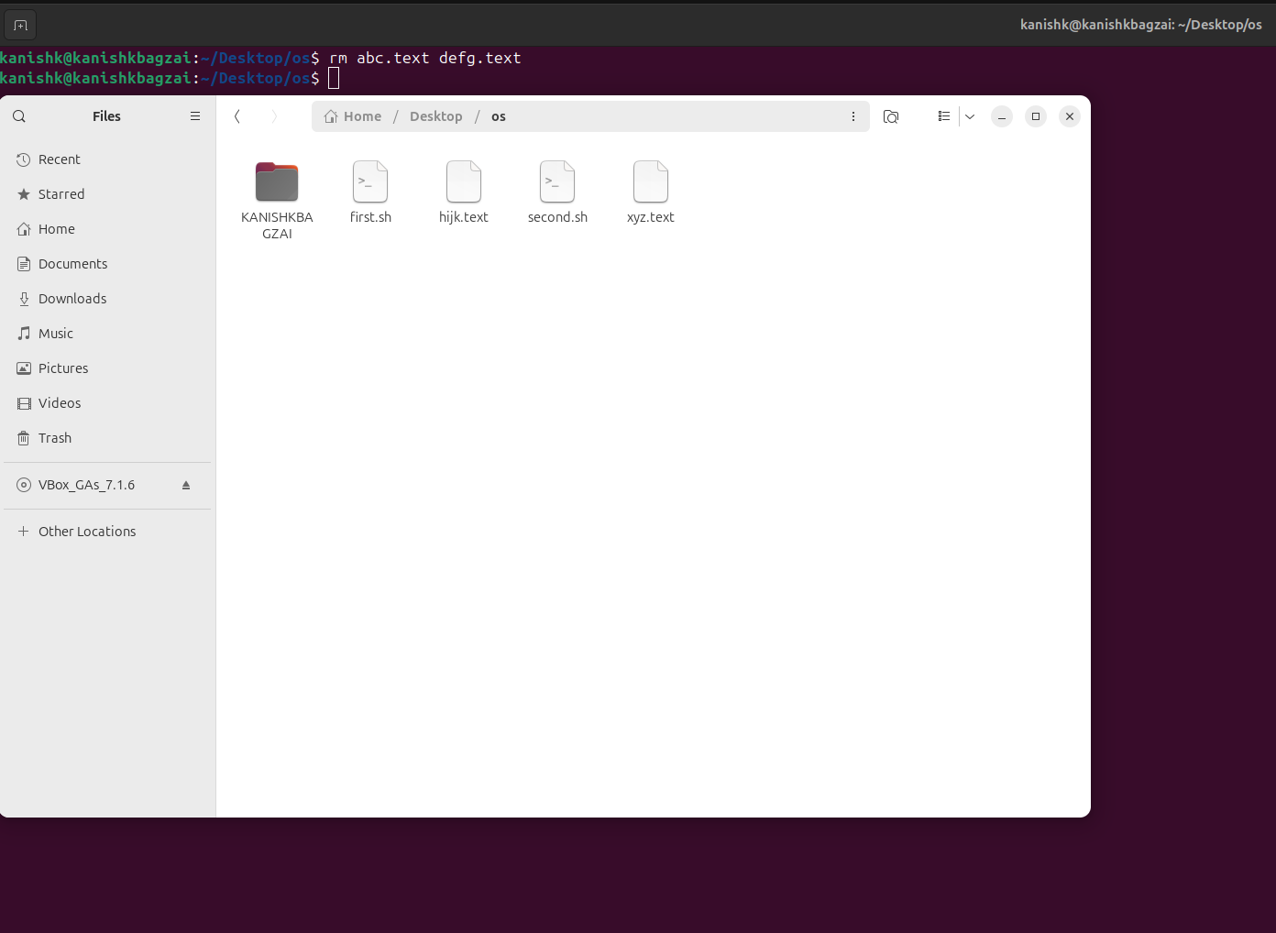

**6.touch** - Creates an emptyfile or updates the timestamp.

9. **chmod** - Changes file permissions.10. **echo** - Displays a line of text.

11. **grep** - Searches for patterns within text.

13. **mv** - Moves or renames files and directories.

14. **cp** - Copies files or directories.

15. **more** - Views file content one screen at a time.

16. **less** - Similar to more, but allows backward navigation.

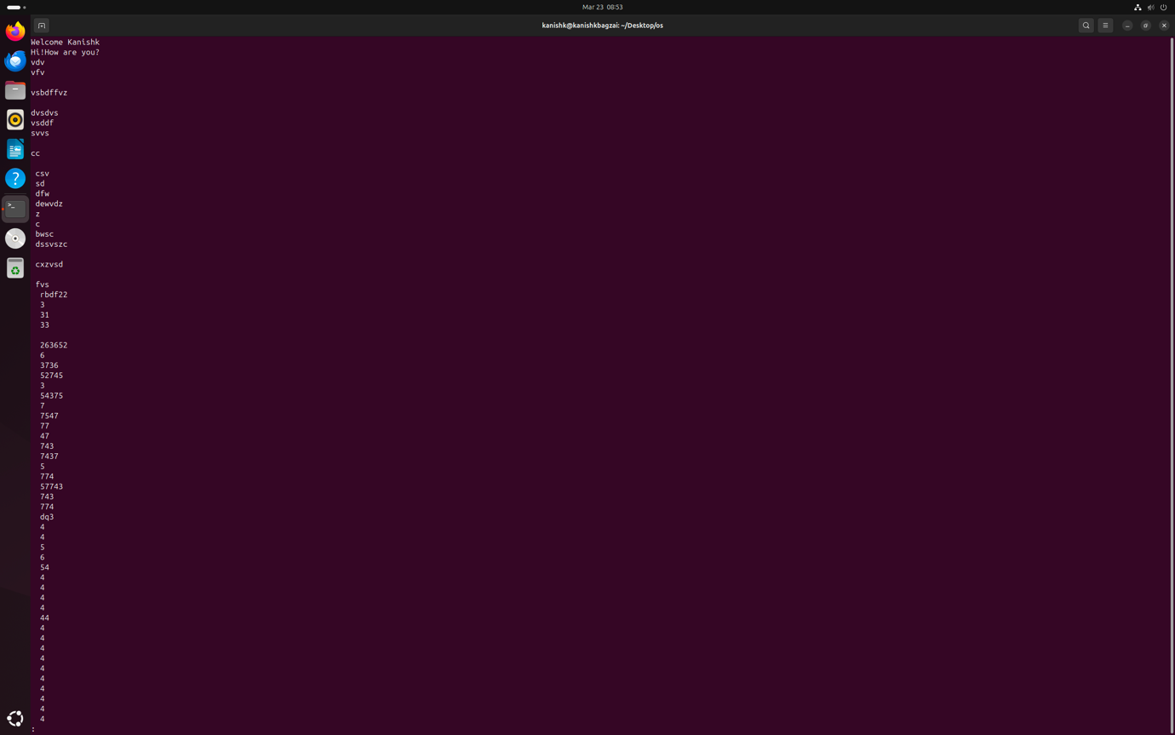

17. **wc** - Counts lines, words, and bytes in a file.18. **awk** - A programming language for text processing.

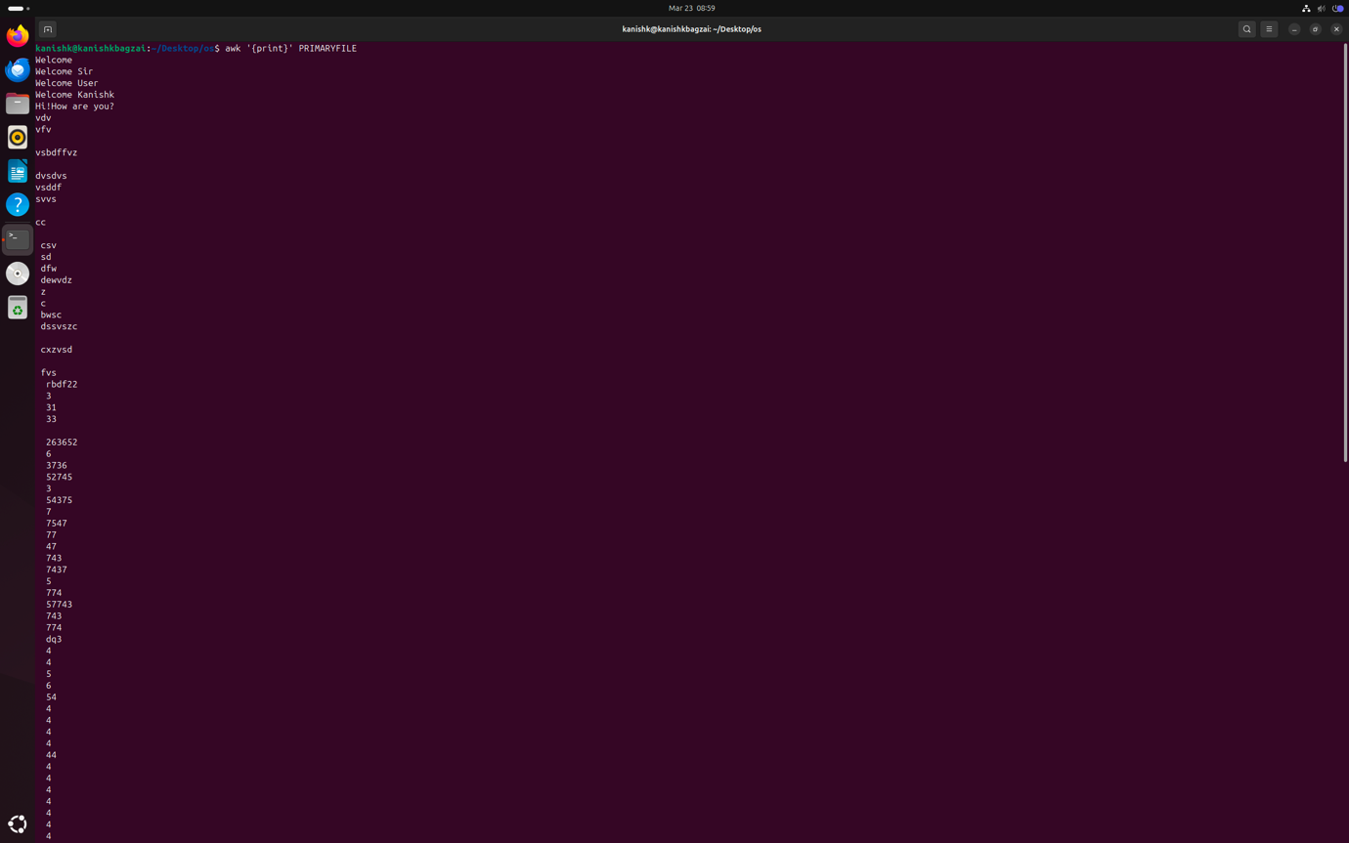19**. sed** - Stream editor for filtering and transforming text.20. **tail** - Displays the last part of a file.

Part 2 Answers to the following Questions: (you need to supply commands)

1. How to navigate to a Specific Directory?

cd /path/to/directory

2.How to see detailed information about files and directories using ls?

ls -l

ls -la # Includes hidden files

3.How to create multiple directories in Linux using `mkdir` command?

mkdir dir1 dir2 dir3

mkdir -p parentdir/subdir1/subdir2 # Create nested

directories

4.How to remove multiple files at once with rm?

rm file1 file2 file3

rm *.txt # Remove all .txt files

5.Can rm be used to delete directories?

rm -r directory_name

rm -rf directory_name # Force remove without prompt

6.How Do You Copy Files and Directories in Linux?

cp file1 /destination/path/

cp -r dir1 /destination/path/ # Copy directory recursively

7. How to Rename a file in Linux Using mv Command

mv old_filename new_filename

8. How to Move Multiple files in Linux Using mv Command

mv file1 file2 file3 /destination/path/

9. How to Create Multiple Empty Files by Using Touch Command in Linux

touch file1 file2 file3

10. How to View the Content of Multiple Files in Linux

cat file1 file2

11. How to Create a file and add content in Linux Using `cat` Command

cat > file.txt

# Type your content

# Press Ctrl+D to save and exit

12. How to Append the Contents of One File to the End of Another File using cat command

cat file1 >> file2

13. How to use cat command if the file has a lot of content and can’t fit in the terminal.

cat largefile.txt | less

or

less largefile.txt

14. How to Merge Contents of Multiple Files Using `cat` Command

cat file1 file2 > merged_file.txt

15. How to use cat Command to Append to an Existing File

cat >> existing_file.txt

# Type your content

# Press Ctrl+D to save and exit

16. What is “chmod 777 “, “chmod 755” and “chmod +x “or “chmod a+x”?

Chmod 777🡪 Grants **read , write , and execute**  to **owner, group, and others**.

Chmod755🡪Grants **read, write, and execute** to the **owner**; **read and execute** to **group and others**.

Chmod +x or chmod a+x. 🡪 Adds **execute** permission for **all (owner, group, others)**.

17. How to find the number of lines that matches the given string/pattern

grep -c "pattern" file.txt

18. How to display the files that contains the given string/pattern.

grep -l "pattern" *.txt

19. How to show the line number of file with the line matched.

grep -n "pattern" file.txt

20. How to match the lines that start with a string using grep

grep "^pattern" file.txt

21. Can the ‘sort’ command be used to sort files in descending order by default?

sort -r file.txt

22. How can I sort a file based on a specific column using the ‘sort’ command?

sort -k 2 file.txt

(Sorts by the second column)